**Abstract:**

The California pitcher plant, *Darlingtonia californica* Torr. (Sarraceniaceae), is a perennial herb endemic to northern California and southwestern Oregonbest known for its highly modified leaves and carnivorous habit. Often found in seeps and bogs, *D. californica* thrives in low nutrient, hydric soils in which most other plants cannot survive, thereby reducing competition. However, as many regions begin to warm from a changing climate, these ecosystems risk drying that could result in the significant reduction of population sizes. There is therefore a critical need to understand the degree of genetic diversity in *D. californica*, since such variation islikely to play an important role in adapting to these challenges. To broaden our currently limited understanding of the genetic status of the species, we sampled twenty individuals from fifteen populations in the four regions in southern Oregon and Northern California. We found that the populations in the Siskiyou region of northern CA possessed much higher levels of genetic diversity relative to the other regions studied. Genetic diversity otherwise declined with distance from this region, suggesting that the species radiated outward from the Siskiyou range during a historical range expansion. With the risk of significant loss of habitat due to climate change and other factors, these genetic data provide valuable insight to assist in the conservation of this rare and unique species.

**Introduction:**

Population genetic variation is a vital aspect to the survival of many endangered species. High genetic diversity provides a population with a mechanism to rapidly respond to ecosystem changes, while low genetic diversity makes a population more susceptible to environmental stressors such as disease and competition (Reed and Frankham, 2003). The importance of genetic diversity has become even greater as anthropogenic climate change has begun to alter relatively stable ecosystems, causing many to species face a significantly increased environmental change that they may not be able to adapt to quickly enough to persist (Havril et al., 2018). Thankfully, some species have shown the ability to rapidly evolve due to intense selective pressure (Berteaux et al., 2004), but this ability is likely dependent on the genetic diversity of the species and therefore conservation efforts of at-risk species could be improved by increasing genetic diversity within populations (Ellstrand and Elam, 1993; Reed and Frankham, 2003; Schierenbeck, 2017). Thus, information on population genetic variability is vital for conservation decisions in species threatened my ecosystem changes in the coming decades.

The Sarraceniaceae consists of three carnivorous genera: *Heliamphora* in Venezuela, *Sarracenia* in the eastern United States, and *Darlingtonia* in Northern California and Oregon. Due to the geographical distribution of the Sarraceniaceae, evolutionary relationships between the genera are still not fully understood (Ellison et al., 2005). The lone, scarcely distributed taxon within the Sarraceniaceae on the west coast of North America is California Pitcher Plant(*Darlingtonia californica*), found in montane regions in Northern California and Southern Oregon. *D. californica* specifically occurs among three distinct, disjunct regions: the Six Rivers and Siskiyou National Forest; the Klamath and Shasta-Trinity National Forests; and the northern Sierra Nevada (Consortium of California Herbaria, 2021). Additionally, a single isolated population is present in a pygmy forest in Mendocino County (Consortium of California Herbaria, 2021). Previous work has shown phenotypic variation in leaf color between these populations, suggesting that there may be adaptive differences between them (Elder, 1997; Rice, 1997, 2006); however, while previous genetic studies have compared *D. californica* to other genera within the Sarraceniaceae, no genetic survey within the species has ever been conducted (Rice, 1997; Karberg and Gale, 2006.). Due to the geographic distances populations (and therefore potentially very low gene flow) between the geographic regions and the high environmental stresses, which drives local adaptation in many plant species (Joshi et al., 2001), there is the potential for significantly different adaptive variation between *D. californica* in each region.

*D. californica* occurs primarily in mesic, serpentine seeps and bogs. These environments are typically characterized as very poor in nutrients (particularly nitrogen, which often acts as the limiting agent for floral growth, see Wolf et al., 1989 and CITE). *D. californica* is able to compensate for these low nutrient levels by utilizing insectivory via its highly modified leaves (Figure 1, see Ellison et al., 2005 and Schulze et al., 1997). While multiple benefit-cost models of carnivory exist, there are clear significant costs associated with this strategy (Givnish et al., 1984; Ellison and Gotelli, 2001). *Darlingtonia* leaves are very inefficient at photosynthesis and its symbiotic carnivorous processes consume a large amount of energy, thus high sunlight and low competition are required for survival (Givnish et al., 1984). The nutrient poor conditions forund in waterlogged seeps and bogs, however, reduce competition by excluding many other species, and are therefore vitally important to the long-term persistence of *D. californica*. correspondingly to these habitats also This is problematic, since as global climate patterns change these ecosystems are expected to receive significantly less snowfall and reduced rates of groundwater recharge (Meixner et al., 2015). The resulting reduction in groundwater levels will likely increase soil nutrient levels over the coming century (CITE), allowing for the introduction of more competition and significantly reducing the benefits associated with carnivory. The long-term future of *D. californica* is therefore uncertain (Jennings and Rhor, 2011).

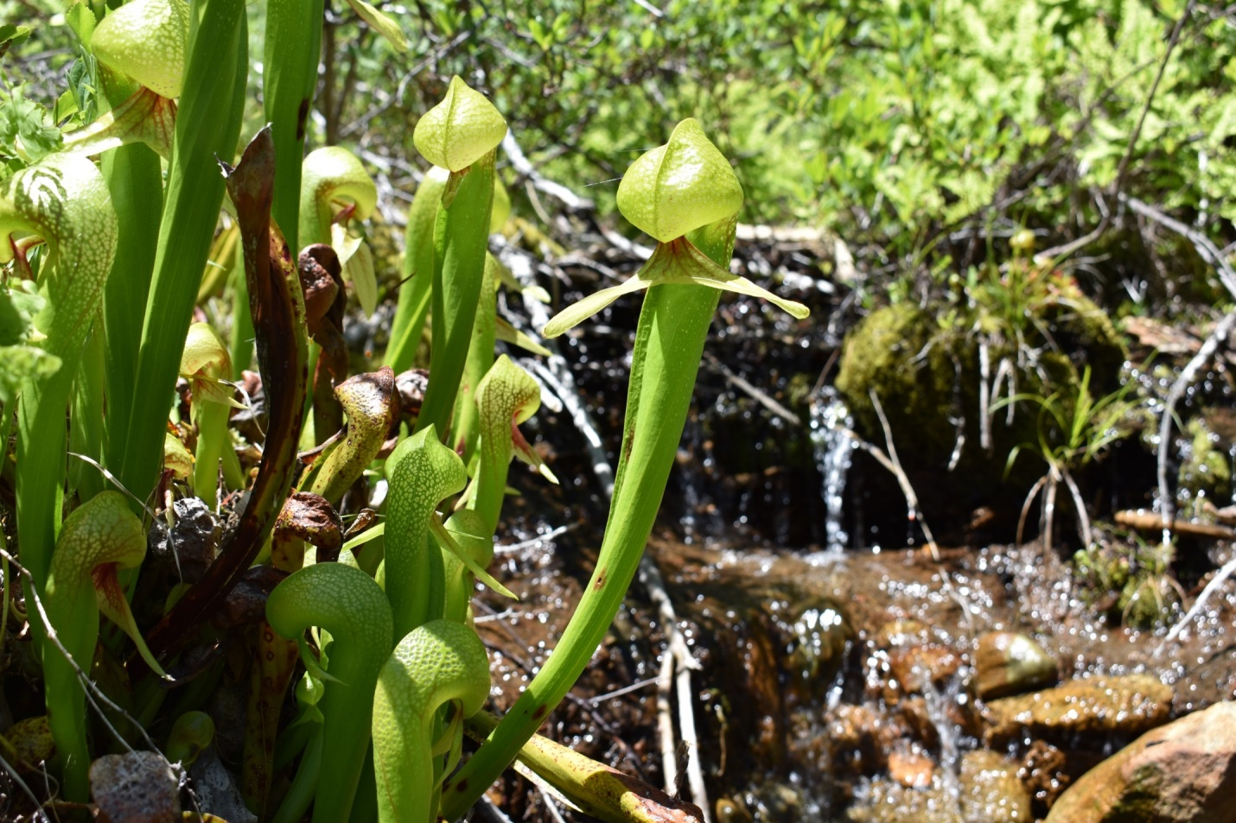

Figure 1. *Darlingtonia californica* Leaves. Photo from Shasta-Trinity National Forest by C. Rice.

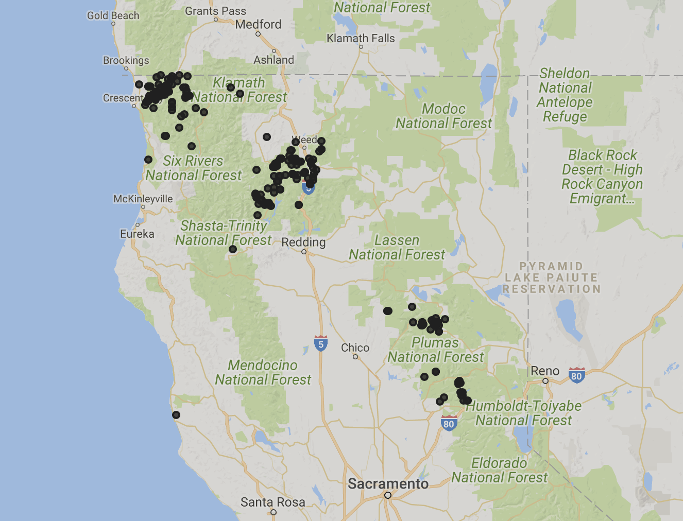

Plumas

Shasta-Trinity

Six Rivers

Mendocino

Figure 2. Locations of identified *Darlingtonia californica* populations in California (Consortium of California Herbaria, 2021). Each point represents a population that a voucher has been collected and deposited into an herbarium associated with the Consortium of California Herbaria. Note some collections were taken prior to GPS, so location data may be approximations. Red circles indicate the separate geographic regions: Six Rivers National Forest, Shasta-Trinity National Forest, Plumas National Forest, and the Mendocino isolate.

In order to estimate baseline levels of genetic diversity within and among populations in *D. californica*, we sampled X individuals from across their range, including at least X individuals from each major geographic region. This information fills a critical knowledge gap and will enable significantly more effective conservation efforts on the species going forward, particularly as the species’ habitat undergoes the changes that it is predicted to experience over the coming decades. Significant inter-regional genotypic differences will indicate which populations may need increased conservation efforts. Additionally, it will identify which populations could benefit from an outbreeding conservation program.

While studies have identified some phenotypic differences in color, very little is known about the distribution of genetic variation within this species, and these differences have not been shown to correlate with various geographic distributions (Elder, 1997; Rice, 1997, 2006). Additionally, *D. californica* onlyoccurs in very wet, nutrient-poor soils which are at an increased risk of loss due to climate change. The loss of these habitats is expected to result in a significant decline in population numbers for this species. Baseline information about genetic diversity within *Darlingtonia* will be critical in determining which populations will benefit from increased conservation efforts. While *D. californica* is considered apparently secure (S4/G4) by NatureServe and California Department of Fish and Wildlife, the species is listed as moderately threatened, ranked 4.2, by the California Natural Diversity Database (2022). In addition to the risk of habitat loss, *D. californica* is threated by horticultural collection due to its unique leaves and symbiotic carnivorous nature. With these threats and the inclusion of *D. californica* on the California Native Plant Society’s Inventory of Rare and Endangered Plants, it is therefore important to take immediate action to protect this unique species (2022).

**Methods:**

Study Species

*Darlingtonia californica*, the California Pitcher Plant (Sarraceniaceae) is a perennial, long-lived dicot herb native to Northern California and western Oregon which possesses bright green stalks with a bulbous, translucent cap growing up to 3 feet (Byrne, 2015). With these highly modified leaves, insects are attracted to sweet secretions on appendages underneath the opening of the leaf (Byrne, 2015). Upon entry, prey often become disoriented with the translucent leaf and fall to its base (Byrne, 2015). The phytotelma, a fluid-filled cavity at the base of the leaves, harbors its own unique ecosystem. Several invertebrates and bacteria are found in the phytotelma and form a complex mutualistic relationship (Brandt, 2017). *Darlingtonia californica* does not produce any digestive enzymes, instead this complex array of organisms is vital to nutrient absorption (Ellison and Farnsworth, 2005). Upon trapping its prey, the microbes within the phytotelma decompose and release nutrients which are then absorbed by the plant. In return, *Darlingtonia* provides important environmental conditions to sustain and protect these species. While many of these mutualists are able to survive externally, it is the unique conditions of the *Darlingtonia* phytotelma that allow them to thrive. On average, 76% of nitrogen in the plant is sequestered via these means (Schulze et al., 1997). While able to undergo rhizomatous growth, *D. californica* sexually reproduces with flower scapes typically 40-60cm tall, producing five crimson petals and twelve to fifteen stamens (Meindl 2009).

*Darlingtonia californica* plays a vital role in the ecology of many species. It is pollinated primarily by the solitary bee, *Andrena nigrihirta* (Meindl, 2009). Despite its symbiotic carnivory, there is no evidence that the plant consumes its pollinator (Meindl, 2009). Several species of spiders and thrips have also been observed on *D. californica* flowers, though they likely play no role in cross pollination between flowers (Meindl & Mesler, 2011). These arachnids and insects likely facilitate self-pollination, which has been extensively observed in *D. californica* (Meindl & Mesler, 2011).

Collections

We collected *D. californica* approximately one gram of leaf tissue from 20 individuals from each of 14 populations selected from each of the Siskiyou, Klamath, northern Sierra Nevada, and Mendocino population units in the summer of 2017 (Figure 2). Due to the ability of *D. californica* to spread via rhizomes, collections were spaced at least 8 meters apart. To prevent deterioration of the genetic samples, the tissues were immediately placed in ice and then stored in a -80˚C freezer within 24 hours

Table 1. Collection sites and voucher accession numbers for collected populations. Vouchers were deposited in the California State University, Chico Herbarium. No vouchers were collected from the Plumas National Forest, populations 8-10, or population 3 in Six Rivers National Forest region due to permitting restrictions.

|  |  |  |  |  |
| --- | --- | --- | --- | --- |
| Population  Number | Location | Coordinates | Accession  Number | Collector |
| 1 | Shasta-Trinity NF | 40º 57’ 46.6” N, 122º 47’ 42.2” W | 120573 | C. Rice |
| 2 | Shasta-Trinity NF | 40º 59’ 07.0” N, 122º 46’ 25.5” W | 120571 | C. Rice |
| 3 | Six Rivers NF | 41° 51' 01.7" N, 123° 54' 27.6" W | No Voucher | C. Rice |
| 4 | Six Rivers NF | 41º 55’ 19.7” N, 123º 52’ 04.2” W | 120577 | C. Rice |
| 5 | Six Rivers NF | 41º 53’ 34.3” N, 123º 51’ 51.8” W | 120572 | C. Rice |
| 6 | Six Rivers NF | 41º 52’ 22.6” N, 123º 53’ 07.5” W | 120569 | C. Rice |
| 7 | Six Rivers NF | 41º 51’ 22.6” N, 123º 54’ 04.7” W | 120575 | C. Rice |
| 8 | Plumas NF | 40º 00’ 46.9” N, 121º 07’ 35.6” W | No Voucher | C. Rice |
| 9 | Plumas NF | 40º 00’ 47.8” N, 121º 07’ 34.7” W | No Voucher | C. Rice |
| 10 | Plumas NF | 40º 00' 06.2" N, 120° 58' 43.3" W | No Voucher | C. Rice |
| 11 | Shasta-Trinity NF | 41º 18’ 48.5” N, 122º 25’ 18.6” W | 120574 | C. Rice |
| 12 | Shasta-Trinity NF | 41º 24’ 23.5” N, 122º 31’ 20.0” W | 120579 | C. Rice |
| 13 | Shasta-Trinity NF | 41º 23’ 08.3” N, 122º 32’ 07.1” W | 120570 | C. Rice |
| 14 | Mendocino County | 39º 15’ 12.5” N, 123º 44’ 47.5” W | 120578 | C. Rice |

Figure 3. Collection sites, not to scale. Each spot indicates a population in which tissue samples were collected. 20 individuals were collected from each site, with the exception of the Mendocino isolate due to low population size. (A) Map showing an overview of collections sites throughout Northern California. (B) Collection sites within the Shasta-Trinity National Forest region. (C) Collection sites within the Plumas National Forest region. (D) Collection sites within the Six-Rivers National Forest region. Satellite and mapping data © Google 2020. Google and the Google logo are registered trademarks of Google LLC, used with permission.

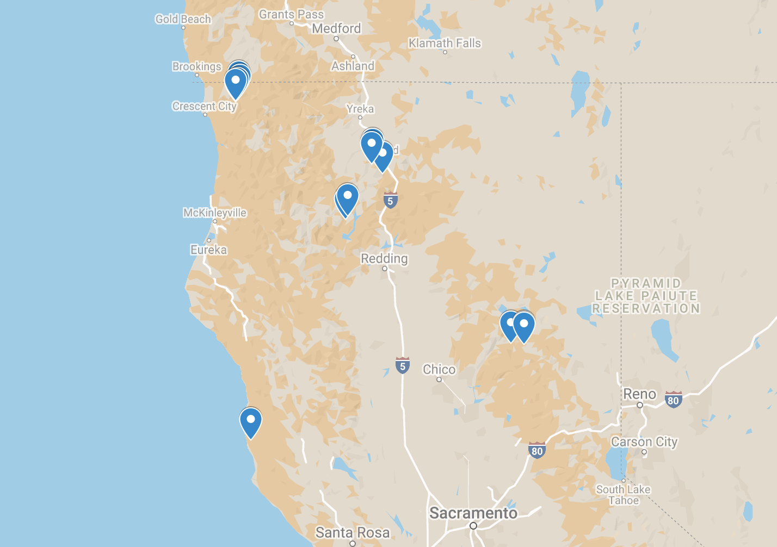

**A**

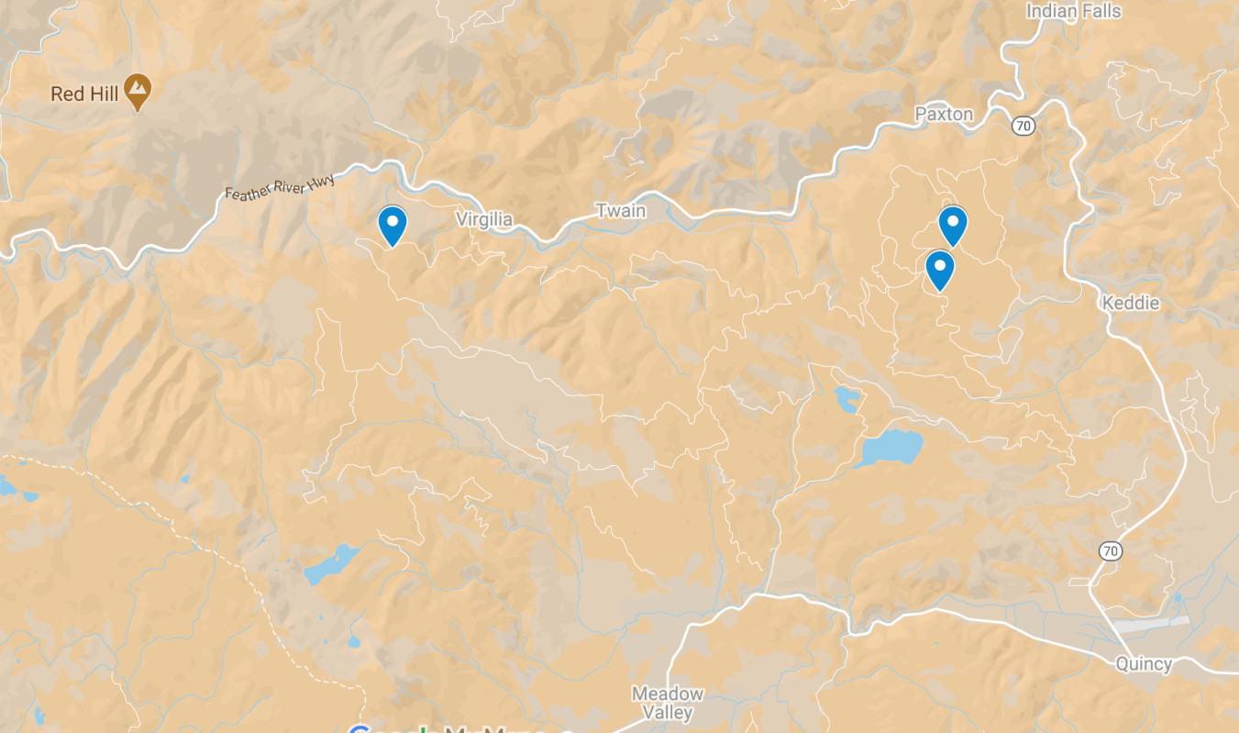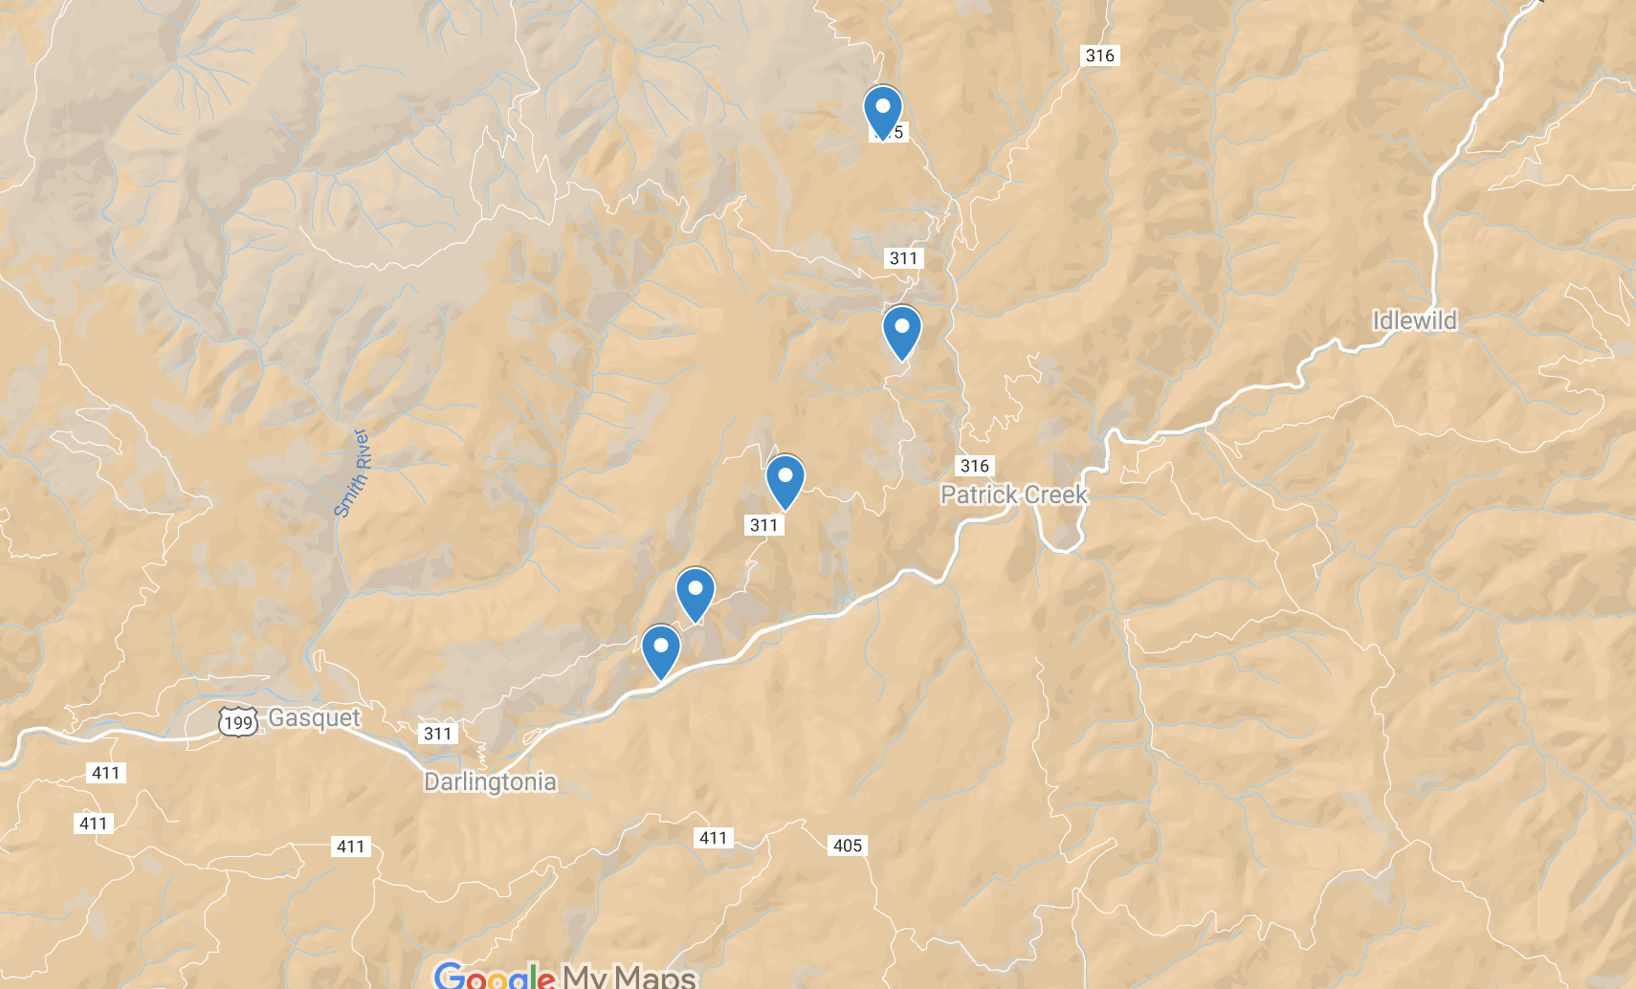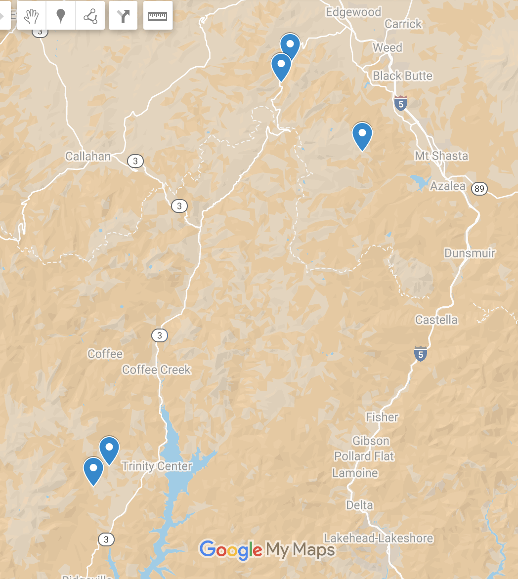

**B**

**C**

**D**

DNA Extractions & RAD Analysis

We used a Qiagen® DNeasy® Plant Mini Kit to isolate and purify DNA samples from the collected tissues, following the manufacturer’s protocol. Samples were disrupted using a mortar and pestle after tissues were flash frozen with liquid nitrogen. Restiriction-associated Digest sequencing (RADseq) libraries were prepared using the protocol described by Ali et al. (2016) and sequenced via 100bp paired-end sequencing on an Illumina HiSeq 2500. RAD sequencing data were demultiplexed by perfect barcode matches and a partial restriction site matches. Given the lack of a reference genome for the species, or for anything closely related, we used a *de novo* approach for locus identification and genotyping using the novoalign (<http://www.novocraft.com/products/novoalign/>) aligner to generate a *de novo* reference genome from the best sequenced sample. As an alternative, we also used Stacks version 2.60 to generate a *de novo* reference genome but saw no improvements (data not shown). We then mapped reads to this genome using the mem algorithm from Burrows-Wheeler Aligner tool (Li and Durbin 2009) and used SAMtools was used to remove PCR duplicates (Li et al. 2009).

Statistical Analysis

In order to describe the general structure of our populations, we conducted a principal component analysis (PCA). Due to the low coverage of our data, we used the Identity-by-State method in the ANGSD software package (Korneliussen et al., 2014) to generate genetic covariance matrices directly and avoid calling individual genotypes. We then scaled and centered these matrices and set missing values to zero following Patterson et al. (2006), then conducted Singular Value Decomposition in R (R Core Team 2021). Since our resulting principal components did not exhibit a sharp decline in the percentage of explained variance, we also used a Uniform Manifold Approximation and Projection (UMAP) dimension-rediction approach to better visiualize higher-order relationships between individuals (McInnes, Healy, and Melville, 2018).

As another alternative, we also used the NGSadmix program to visualize the relationships between our samples (Skotte et al. 2013). Briefly, NGSadmix is strongly analgous to the widely-used program STRUCTURE (Pritchard et al. 2000) in that uses a Bayesian algorithm to group individuals into *k* clusters that best fit the standard assumptions of ideal populations but uses genotype likelihoods instead of called genotypes and thus functions better in low-coverage datasets (Skotte et al. 2013). To understand how our results varied across runs, we ranNGSadmixten times for each value of *k* between one and 13We used the delta-Kmethod to *k* ). We condensed results across runs at each *k* value using CLUMPP (Jakobsson and Rosenberg 2007), then visualized the resulting plots using the pophelper and snpR R packages (Francis 2017; Hemstrom & Jones, 2022).

In order to describe the basic genetic diversity levels of each population, we first called genotypes using the ANGSD software package with the settings X. We then used the snpR R package (Hemstrom & Jones, 2021) to calculate observed heterozygosity (HO), expected heterozygosity (HE), and determine the number private alleles (PA) found in each population after filtering out sample missing more that 75% of genotypes, loci ungenotyped in more than 75% of individuals or significantly out of HWE according to Wigginton et al. (2005) at α = 0.05 after multiple testing correction in any region (Holm 1979).

**Results:**

We sequenced a total of 19,276,234 reads across all individuals. Our PCA results from the IBS covariance matrix generally separated the Six Rivers region from the Shasta-Trinity and Plumas regions along the first PC, which explained 10.8% of the variance in the dataset (Figure S1A). Additional PCs did not show a sharp drop-off in explanatory power at any point (Figure S1B). The UMAP analysis also strongly splits Six Rivers from Shasta-Trinity and Plumas, but also splits the latter two systems to a lesser degree (Figure 4). Interestingly, the Mendocino population clustered strongly with the samples from the Plumas region.

Darlingtonia/umap.pdfFigure 4. UMAP analysis of individuals. Numbering and color denote specific populations. Populations 1-2, 11-13 are from Shasta-Trinity; 3-7 are from Six Rivers; 8-10 are from Plumas; while 14 is the Mendocino isolate. Dashed ovals represent approximate groupings of the regions.

Six Rivers

Shasta-Trinity

Plumas & Mendocino

Shasta-Trinity NF

Six Rivers NF

Plumas NF

Mendocino

Population

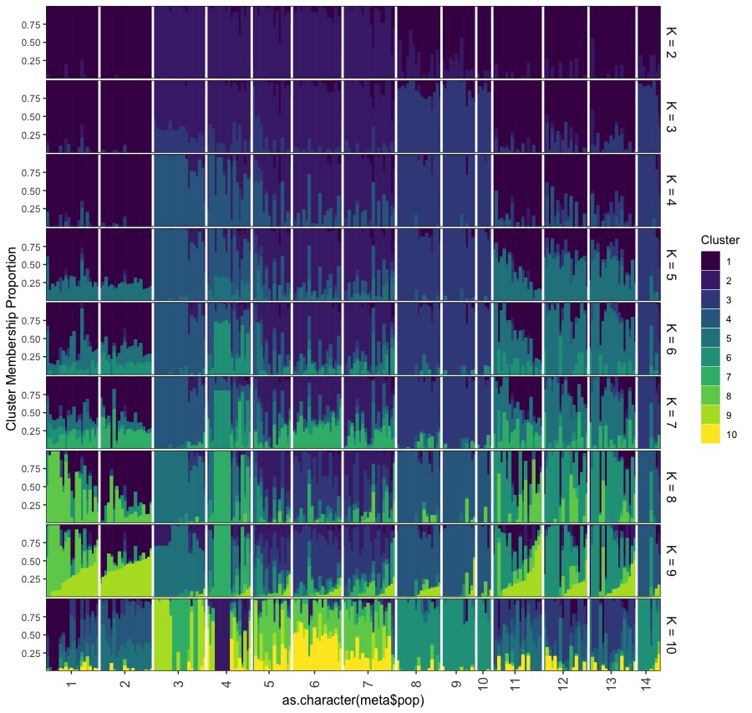

Figure 5. NGSadmix analysis of *Darlingtonia* collections. Coloring indicates different clusters at various values ofK*.* Each bar represents an individual within the populations.

Figure 6. Delta K plot of samples in the STRUCTURE analysis.

These results were largely consistent with those from our STRUCTURE analysis, for the highest Delta K was reached at *k* = 2 (Figure S2), where Six Rivers was also split from the Shasta-Trinity and Plumas regions (Figures 5). Higher *k* value split the Plumas region from Shasta-Trinity, but Mendocino population was again indistinguishable from the Plumas region across all values of *k* (Figure 5). Higher *k* values show little additional structuring, aside from some minor differentiation within the Six Rivers region (not shown). Overall, however, genetic differentiation appears to be driven by regional rather than local differentiation.











For our SNP data, we were able to call 87 SNPs in 124 samples after filtering. However, most of these SNPs exhibited maximized heterzygosity (with all minor alleles in the heterozygous state regardless of frequency), suggesting that the genotyping process may not have been robust, which is unsurprising given our generally poor sequencing success (see Figure S3). Our diversity estimates are therefore not particularly trustworthy outside of the private allele frequencies which are less likely to be biased by genotying errors as long as polymorphisms are successfully recovered within populations. We found the highest number of private alleles in the Six Rivers region (16), followed by Shasta-Trinity (6). We found no private alleles in the plumas or Mendicino populations either separately or pooled.

**Discussion:**

Geographic Regions

Each of our genetic differentiation tests (UMAP, FST, and STRUCTURE) indicate that *D. californica* individuals in each region are distinct, with the exception of the Mendicino populations which grouped with those from the Plumas National Forest. Since the regions were confirmed to be distinct, I next looked for the genetic diversity within each region. One measure for determining genetic diversity among populations is by examining the number of private alleles found in each. Private alleles refer to SNP alleles that are unique to a population and not found in any other population. Greater numbers of private alleles indicate an increased richness in the genetic profile of a population. With the private allele analysis, Six Rivers National Forest was the most genetically diverse region with 9 total private alleles throughout the region, an average of 1.8 per population collected. Meanwhile, no private alleles were discovered in the Plumas National Forest or the Mendocino population. The pattern suggests a radiation of individuals from the Six Rivers region to Plumas, as Shasta-Trinity has a medium number of private alleles. Heterozygosity is another important measure of genetic diversity. Increased numbers of heterozygous individuals correlate with increased diversity, as more allelotypes are present in the population. The relatively low heterozygosity observed in Plumas National Forest therefore further corroborates the lack of diversity in the region. While phenotypic coloration differences have been observed in *D. californica* individuals (Elder, 1997; Rice, 1997, 2006), I found no notable differences in coloration patterns between the geographic regions observed. However, populations occurring in Six Rivers appeared notably taller than the other regions. Though this could be explained by environmental causes as Six Rivers populations are at significantly lower elevations than Shasta-Trinity or Plumas populations, with mean elevations of 574 m, 1576 m, and 1242 m respectively. Thus, Six Rivers populations likely benefit from increased growing seasons from relatively less seasonal snowfall.

Biogeography of Sarraceniaceae

The distribution pattern of decreasing genetic diversity correlating with increasing distance from the Six Rivers populations suggests a possible dispersal route for *Darlingtonia*. This may provide greater insight into the evolutionary history of *Darlingtonia* and the greater Sarraceniaceae. Some have suggested the disjointed distribution of the Sarraceniaceae, with *Sarracenia* in the eastern United States and *Heliamphora* in northern South America, could be explained by dispersion events from a single point of origin (Neyland & Merchant, 2006). However, a wide, connected distribution of the Sarraceniaceae throughout North and South America until fragmentation occurred from climatic changes has also been hypothesized (Renner, 1989). Later genetic work suggest Sarraceniaceae originated in South America 44-55 million years ago and became widespread throughout the Americas during the Eocene (Ellison et al., 2012). Present-day Sarraceniaceae seeds are hydrophobic allowing for rare longer distance dispersal events of 1-10 m (Ellison & Parker, 2002; Schwaegerle, 1983) which could explain its rapid dispersal across the continental gap in the Eocene, using land masses in the proto-Caribbean. *Darlingtonia* diverged from the *Heliamphora+Sarracenia* clade in the Late Eocene, approximately 35 million years ago (Ellison et al., 2012). *Heliamphora* and *Sarracenia* diverged in the Late Oligocene, approximately 23 million years ago (Ellison et al., 2012). These disruption events coincide with major climatic changes throughout the period including glaciation and drying events (Greenwood & Wing, 1995). The influence of these changes may have been tempered in the Klamath mountains due to their location near the coast. It is likely this region acted as a refuge for *Darlingtonia* after it became disconnected from the *Heliamphora+Sarracenia* clade due to these climatic changes. As the climate began to stabilize towards the present-day, dispersion events from this refuge allowed *Darlingtonia* to spread to the Trinity Alps and Sierra Nevada. The drops in diversity seen in the Shasta-Trinity and Plumas are likely examples of genetic bottlenecking from the founder effect of these dispersion events.

Mendocino Isolate

One area of particular initial interest was the isolate population in Mendocino county. This population is located over 100 miles from the nearest other population in Shasta-Trinity National Forest (Consortium of California Herbaria, 2021). However at the location of the population growth, I discovered several other carnivorous plants. This included carnivorous plants native to California, such as *Drosera* sp*.* (Droseraceae)and multiple species of the non-native *Sarracenia* sp*.* (Sarraceniaceae). *Sarracenia* sp.is native to the Southeastern United States and is not naturally found in California. According to collection records from the Consortium of California Herbaria, three distinct taxa have been found at this location in Mendocino County, *S. leucophylla*, *S. rosea*, and *S. oreophila* (2021). Given the abundance of other carnivorous species, especially those non-natives, and the sheer degree of isolation of this population, these *Darlingtonia* specimens were almost certainly artificially introduced to this location. Since the genetic profile of this population nearly identically matches those of the Plumas region, this population was likely sourced, via transplantation or seeds, from that region.

Recommendations

With the lack of previous genetic studies within *Darlingtonia*, it remained unclear the extent of the separation between geographic regions and whether that should be represented in the taxonomic classification of the species. While my work was limited by poor DNA yields, I was able to find conclusive differences between the geographic regions. However, I was unable to determine if these differences were substantial enough to subdivide the species. Additionally, while some phenotypic differences were observed, there was no significant distinctions which could not be explained by environmental conditions. Therefore, at present time, there does not appear to be sufficient data to justify the distinction of subspecies in *D. californica*.

*Darlingtonia californica* unfortunately faces many threats, primarily from habitat loss, increased competition, and horticultural collections. In order to combat these threats, several approaches could prove beneficial. First-line measures include preventing development of these habitats and limiting collections (Schierenbeck, 2014). However with these regions experiencing reduced groundwater recharge in a changing climate (Meixner et al., 2015), additional measures may be needed. Populations in the Plumas region maintain the lowest genetic diversity of *D. californica*, thus these areas are the least likely to adapt to changing conditions. Therefore Plumas may benefit from an artificial outbreeding program using pollen or seeds from the more diverse Six Rivers region. While it is impossible to predetermine whether this approach would prevent loss of these habitats, maintaining a diverse population provides a much stronger defense. In addition to these programs in Plumas National Forest, Six Rivers populations should be strongly protected against anthropogenic habitat destruction. Previous work and these data suggest Six Rivers region has acted as a climate refuge for *Darlingtonia* for millions of years (Ellison et al., 2012). This coastal region and genetic diversity provides these populations with a strong defense against the effects of climate change. Therefore, the most pertinent action for this region would be to protect these populations from human development.

Conclusions

*Darlingtonia californica* is a unique species, with its limited range and symbiotic carnivorous microbiome. Though with decreasing potential habitats, populations with reduced fitness are at a substantial risk of disappearing in the next few decades. Since greater diversity is correlated with fitness, populations with reduced genetic richness are at an increased risk (Ellstrand and Elam, 1993; Reed and Frankham, 2003; Schierenbeck, 2017). Populations in the Six Rivers region are likely in the safest position due to their high heterozygosity and private allele counts. Additionally, their location closer to the coast may prove advantageous as it provides a more stable access to rainfall recharge relative to more inland populations (Meixner et al., 2015). Plumas populations are likely at the greatest risk due to their inland location and reduced diversity. Introduction of new genes through artificial means, such as an outbreeding program, from other regions may therefore be beneficial to these populations. While some analyses were limited by poor DNA extraction yields, I was able to find overarching patterns of dispersal of *D. californica* from the Six Rivers region inland towards the Sierra Nevada. Further work is needed to provide greater detail into the exact phylogeography of the species and the speciation of *Darlingtonia* from *Sarracenia*. Future studies could additionally benefit from sampling populations along the Oregon coast, of which I was unable to collect due to strict permitting restrictions in the state. Ultimately these data can hopefully guide forest managers to protect this incredible species.

REFERENCES

Ali OA, O’Rourke SM, Amish SJ, Meek MH, Luikart G, Jeffres C, Miller MR. 2016. *Genetics 202*: 389-400.

Berteaux D, Réale D, McAdam AG, Boutin S. 2004. Keeping Pace with Fast Climate Change: Can Artic Life Count on Evolution? *Integrative and Comparative Biology 44*(2): 140-151.

Brandt S. 2017. *Darlingtonia californica* phytotelma organisms: spatial relations within the metacommunity [Master’s thesis]. *Humboldt Digital Scholar*.

Byrne MK. 2015. *Plant of the Week: California Pitcherplant (Darlingtonia californica).* United States Forest Service*.*

California Native Plant Society. 2022. *Inventory of Rare and Endangered Plants of California (online edition, v8-03 0.39).*

California Natural Diversity Database (CNDDB). 2022. *Special Vascular Plants, Bryophytes, and Lichens List.* California Department of Fish and Wildlife.

Consortium of California Herbaria. 2021. *Darlingtonia californica*. CCH2 Portal.

Davey JW, Blaxter ML. 2011. RADSeq: next generation population genetics. *Briefings in Functional Genomics 9*(5): 416-423.

Dray S, Josse J. 2015. Principal component analysis with missing values: a comparative survey of methods. *Plant Ecology 216*: 657-667.

Edmands S. 2007. Between a rock and a hard place: evaluating the relative risks of inbreeding and outbreeding for conservation and management. *Molecular Ecology 16*(3): 463-475.

Elder CL. 1997. Reproductive biology of *Darlingtonia californica* [Master’s thesis]. *Humboldt Digital Scholar*.

Ellstrand NC, Elam DR. 1993. Population genetic consequences of small population size: implications for plant conservation. *Annual Review of Ecological Systems 24*: 217-242.

Ellison AM, Butler ED, Hicks EJ, Naczi RFC, Calie PJ, Bell CD, Davis CC. 2012. Phylogeography and Biogeography of the Carnivorous Plant Family Sarraceniaceae. *PLoS One 7*(6): e39291.

Ellison AM, Farnsworth EJ. 2005. The cost of carnivory for *Darlingtonia californica* (Sarraceniaceae): evidence from relationships among leaf traits. *American Journal of Botany 92*(7): 1085-1093.

Ellison AM, Gotelli NJ. 2001. Evolutionary ecology of carnivorous plants. *TRENDS in Ecology & Evolution 16*(11): 623-629.

Ellison AM, Gotelli NJ, Brewer S, Cochran-Stafira DL, Kneitel JM, Miller TE, Worley AC, Zamora R. 2005. Phylogeny and Biogeography of the Carnivorous Plant Family Sarraceniaceae. *Advances in Ecological Research 33:* 2-64.

Ellison AM, Parker JN. 2002. Seed dispersal and seedling establishment of *Sarracenia purpurea* (Sarraceniaceae). *American Journal of Botany 89*: 1024-1026.

Evano G, Regnaut S, Goudet J. 2005. Detecting the number of clusters of individuals using the software STRUCTURE: a simulation study. *Molecular Ecology 14*(8): 2611-2620.

Givnish TJ, Burkhardt EL, Happel, RE, Weintraub JD. 1984. Carnivory in the bromeliad *Brocchinia reducta*, with cost/benefit model for the general restriction of carnivorous plants to sunny, moist, nutrient-poor habitats. *The American Naturalist 124*(4): 479-497.

Greenwood D, Wing, S. 1995. Eocene continental climates and latitudinal temperature gradients. *Geology 23*: 1044-1048.

Hohenlohe PA, Bassham S, Etter PD, Stiffler N, Johnson EA, Cresko WA. 2010. Population genomics of parallel adaptation in threespine stickleback using sequenced RAD tags. *PLoS Genetics 6*(2): e1000862.

Jennings DE, Rohr JR. 2011. A review of the conservation threats to carnivorous plants. *Biological Conservation 144*: 1356-1363.

Joshi J, Schmid B, Calderia MC, Dimitrakopoulos PG, Good J, Harris R, Hector A, Huss-Danell K, Jumpponen A, Minns A, Mudler CPH, Pereira JS, Prinz A, Scherer-Lorenzen M, Siamantziouras ASD, Terry AC, Troumbis AY, Lawton JH. 2001. Local adaptation enhances performance of common plant species. *Ecology Letters* *4*(6): 536-544.

Havril T,  Tóth Á, Molson JW, Galsa A, Mádl-Szőnyi J. 2018. Impacts of predicted climate change on groundwater flow systems: Can wetlands disappear due to recharge reduction? *Journal of Hydrology 563*: 1169-1180.

Hemstrom W, Jones M. 2021. snpR: user friendly population genomics for SNP datasets with categorical metadata. *Authorea*.

Karberg JM, Gale MR. 2006. Genetic diversity and distribution of *Sarracenia purpurea* (Sarraceniaceae) in the western Lake Superior basin. *Canadian Journal of Botany 84*: 235-242.

Kardos M, Armstrong EE, Fitzpatrick SW, Hauser S, Hedrick PW, Miller JM, Tallmon DA, Funk WC. 2021. The crucial role of genome-wide genetic variation in conservation. *PNAS 118*(48): e2104642118.

Kiers HAL. 1997. Weighted least squares fitting using ordinary least squares algorithms. *Psychometrika 62*(2): 251-266.

Korneliussen TS, Albrechtsen A, Nielsen R. 2014. ANGSD: Analysis of Next Generation Sequencing Data. *BMC Bioinformatics* *15*: 356.

McInnes L, Healy J, Melville J. 2018. UMAP: Uniform manifold approximation and projection for dimension reduction. *Arxiv.*

Meindl GA. 2009. Pollination biology of *Darlingtonia californica*, the California pitcher plant [Master’s thesis]. *Humboldt Digital Scholar*.

Meindl GA, Mesler MR. 2011. Pollination Biology of *Darlingtonia californica* (Sarraceniaceae), the California Pitcher Plant. *Madroño 58*(1): 22-31.

Meixner T, Manning AH, Stonestrom DA, Allen DM, Ajami H, Blasch KW, Brookfield AE, Castro CL, Clark JF, Gochis DJ, Flint AL, Neff KL, Niraula R, Rodell M, Scanlon BR, Singha K, Walvoord MA. 2015. Implications of projected climate change for groundwater recharge in the western United States. *Journal of Hydrology 534*: 124-138.

Nei M. 1977. F-statistics and analysis of gene diversity in subdivided populations. *Annals of Human Genetics, London 41*: 225-233.

Neyland R, Merchant M. 2006. Systematic relationships of Sarraceniaceae inferred from nuclear ribosomal DNA sequences. *Madroño 53*: 223-232.

Porras-Hurtado L, Ruiz Y, Santos C, Phillips C, Carracedo Á, Lareu M. 2013. An overview of STRUCTURE: applications, parameter settings, and supporting software. *Frontiers in Genetics 4*(98).

Pritchard JK, Stephens M, Rosenberg NA, Donnelly P. 2000. Association mapping in structured populations. *American Journal of Human Genetics*, *67*(1), 170–181.

Reed DH, Frankham R. 2003. Correlation between fitness and genetic diversity. *Conservation Biology 17*(1): 230-237.

Renner SS. 1989. Floral biological observations on *Helimaphora tatei* (Sarraceniaceae) and other plants from Cerro de la Neblina in Venezuela. *Plant Systematics Evolution 163*: 21-29.

Rice BA. 1997. An anthocyanin-free variant of *Darlingtonia californica*: Newly discovered and already imperiled. *Carnivorous Plant Newsletter* *26*: 129-132.

Rice BA. 2006. *Growing Carnivorous Plants*. Portland, OR: Timber Press, Inc.

Schierenbeck KA. 2014. *Phylogeography of California*. Oakland, CA: University of California Press.

Schierenbeck KA. 2017. Population-level genetic variation and climate change in a biodiversity hotspot. *Annals of Botany 119*: 215-228.

Schulze W, Schulze ED, Pate JS, Gillison AN. 1997. The nitrogen supply from soils and insects during growth of the pitcher plants *Nepenthes mirabilis, Cephalotus follicularis,* and *Darlingtonia californica*. *Oecologia 112*: 464-471.

Schwaegerle KE. 1983 Population growth of the pitcher plant, *Sarracenia purpurea* L., at Cranberry Bog, Licking County, Ohio. *Ohio Journal of Science 83*: 19-22.

Teixeria JC, Huber CD. 2021. The inflated significance of neutral genetic diversity in conservation genetics. *PNAS 118*(10): e2015096118.

Wickham H. 2016. *ggplot2: Elegant Graphics for Data Analysis*. Springer-Verlag New York.

Wolf J, De Wit CT, Van Keulen H. 1989. Modeling long-term crop response to fertilizer and soil nitrogen: I. Model description and application. *Plant and Soil*, *120*(1): 11–22.

Wright, S. 1951. The genetical structure of populations. *Annals of Eugenics 15*: 323-354.

Wright, S. 1965. The interpretation of population structure by F-statistics with special regard to systems of mating. *Evolution 19*: 395-420.